**7. ReactJS – HOL**

**1. Define Props**

* Props means "properties".
* They are used to pass data from one component (parent) to another (child).
* Props are read-only – they cannot be changed by the child component.
* Think of props like arguments passed into a function.

**Example:**

function Welcome(props) {

return <h1>Hello, {props.name}</h1>;

}

// Usage

<Welcome name="Priii" />

**2. Explain Default Props**

* Sometimes a component may **not receive a prop**.
* You can set **default values** for props using defaultProps.
* This ensures the component still works even if some props are missing.

**Example:**

function Greet(props) {

return <p>Welcome, {props.name}</p>;

}

Greet.defaultProps = {

name: "Guest"

};

**If used like this:** <Greet />  
**Output:** Welcome, Guest

**3. Identify the Differences Between State and Props**

|  |  |  |
| --- | --- | --- |
| **Feature** | **Props** | **State** |
| What is it? | Data passed from parent to child | Data that belongs to the component |
| Editable? | Read-only | Can be changed with setState() |
| Usage | Used for **input** (data to the component) | Used for **output** (data that changes inside) |
| Ownership | Controlled by **parent component** | Controlled by **the component itself** |

**4. Explain ReactDOM.render()**

* It is used to render the React component into the actual HTML DOM.
* This is the starting point of every React app.
* It tells where to display the React component in the webpage.

**Syntax:**

ReactDOM.render(<App />, document.getElementById('root'));

* <App /> is the component to show.
* 'root' is the ID of the HTML element (usually in index.html) where React will load your UI.

**React Application : shoppingapp**

Create a React Application named “shoppingapp” with a class component named “OnlineShopping” and “Cart”.

1. In Cart class, create 2 properties as mentioned below:

* Itemname
* Price

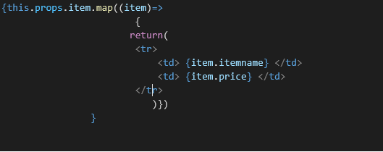

1. In OnlineShopping class, create an array of Cart and initialize 5 items.

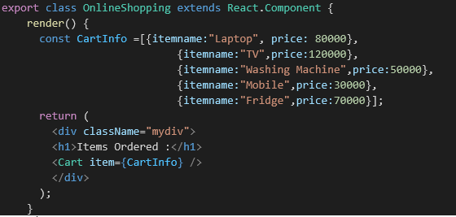

1. Loop through these items and display the data as shown below:

**Final Output:**

